
Sukkur IBA University
Department of Computer Science
ESE-201: Digital Logic Design Lab

Lab # 05: Implementation of FULL Adder using gate ICS’s

Name: Majid Ali
CMS ID: 053-25-0017
Course: DLD (Lab:5)
Section: Software Enineering (A)

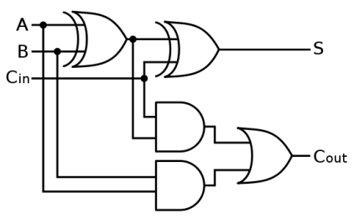

Lab Learning Objectives:

Upon successful completion of this experiment, the student will be able:
- To implement and verify 4 bit Parallel Adder by IC 74283

Lab Hardware and Software Required:
- 74283 IC
- Module KL-33001 / Elvis II
- Breadboard
- Connecting Wires

IMPLEMENTATION OF FULL ADDER Using AND, OR and XOR gate ICs:

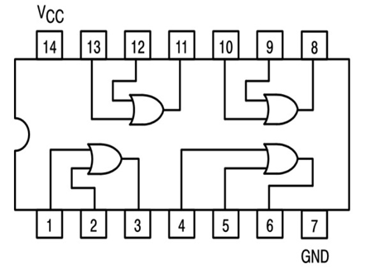

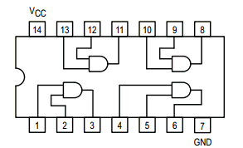

Fig 1.4: 74LS08 2-input AND gate IC pin configuration

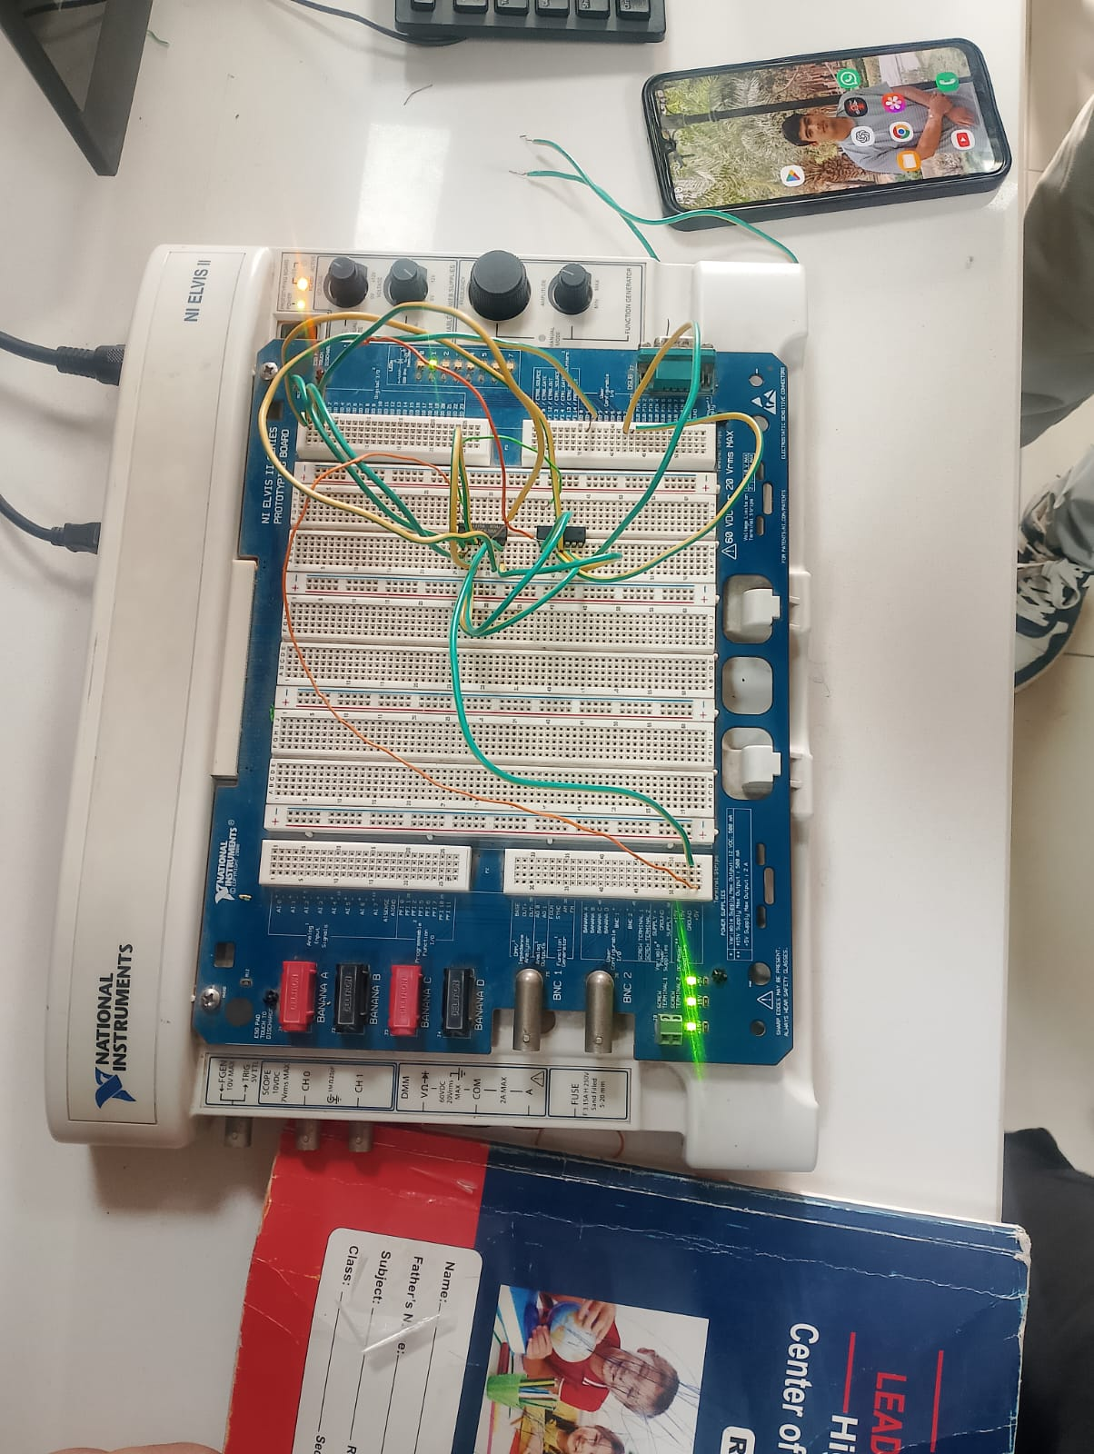
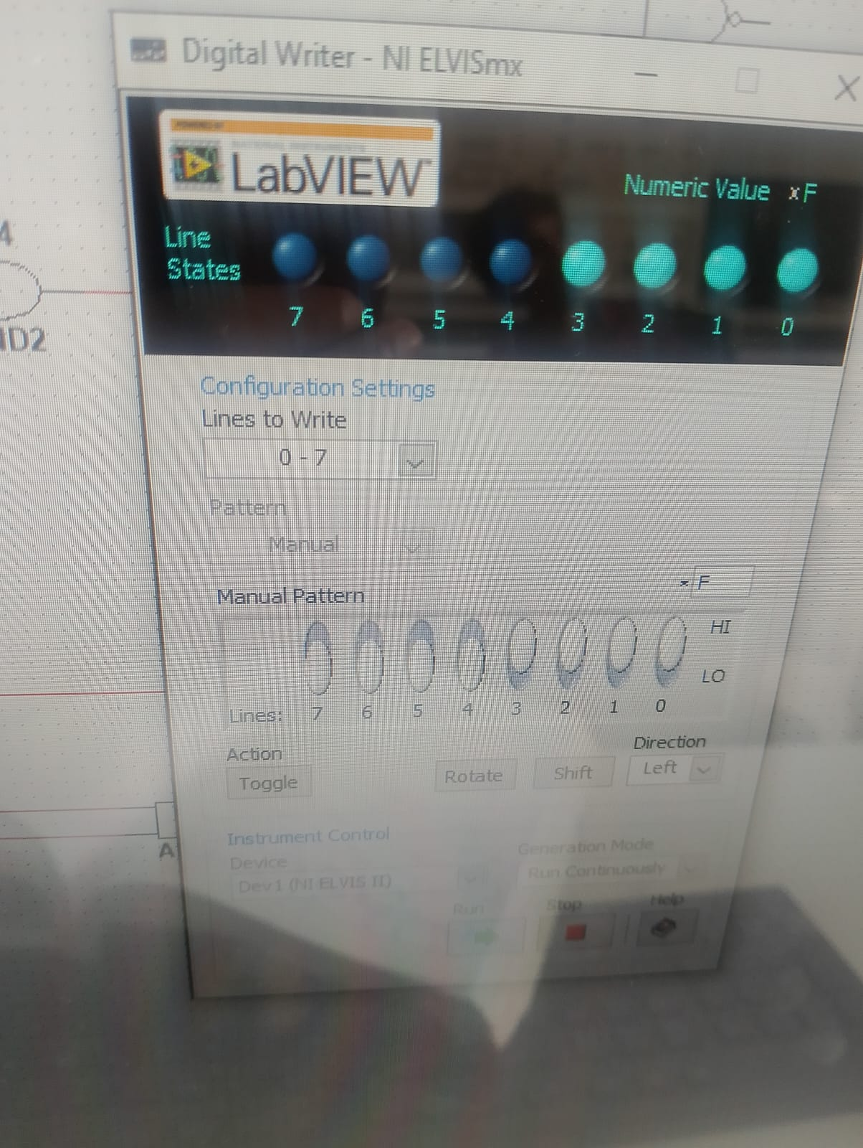

OR gate IC pin configuration
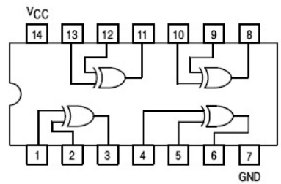
Fig 3.2: 74LS86 2-input X-OR gate IC pin configuration

Input |  |  | Output |  | Output
X | Y | Z | (Sum ∑) | Carry
0 | 0 | 0 | 0 | 0
0 | 0 | 1 | 1 | 0
0 | 1 | 0 | 1 | 0
0 | 1 | 1 | 0 | 1
1 | 0 | 0 | 1 | 0
1 | 0 | 1 | 0 | 1
1 | 1 | 0 | 0 | 1
1 | 1 | 1 | 1 | 1
Table 4.2: Observation table of 1-bit Full Adder

